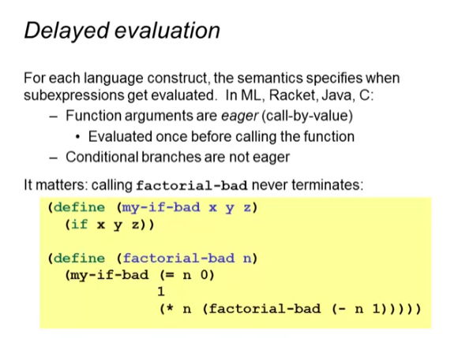

factorial-normal

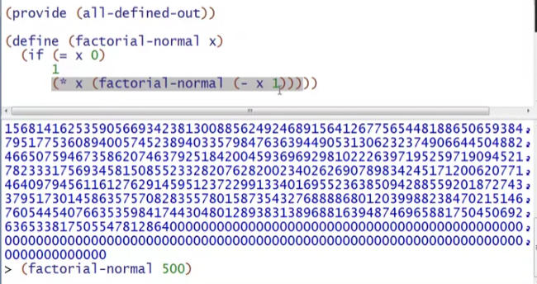

my-if-bad & factorial-bad Functions

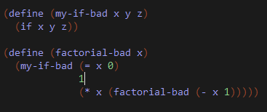

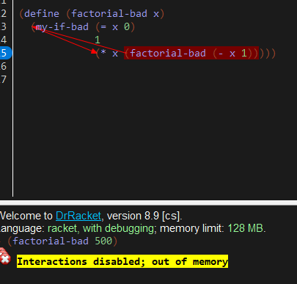

Why is it like this?

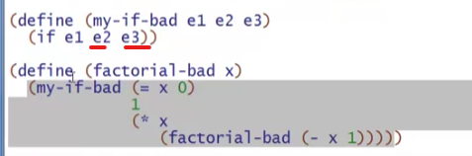

* Because these 2 exp are both EVALUATED every time! Unlike in the normal conditional statement, it only evaluates 1 branch
* e2 and e3 here are EXPRESSIONS that are evaluated immediately

3rd version: my-if-strange-but-works

* Wrapping e2 and e3 with parenthesis



* (e2) and (e3) is a FUNCTION CALL, evaluation only works if they are called!

Using this:

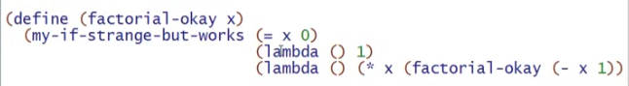

* e2 and e3 must be functions
* body of the functions will only be evaluated once the functions are called

